**EXPERIMENT NO: 03**

**Title**: Draw an E-R Diagram for any organization.

**Aim:** Draw an E-R Diagram for any organization.

Purpose of Database system or advantages of Database system or

ER model

* ER model stands for an Entity-Relationship model. It is a high-level data model. This model is used to define the data elements and relationship for a specified system.
* It develops a conceptual design for the database. It also develops a very simple and easy to design view of data.
* In ER modeling, the database structure is portrayed as a diagram called an entity-relationship diagram.

**For example,** Suppose we design a school database. In this database, the student will be an entity with attributes like address, name, id, age, etc. The address can be another entity with attributes like city, street name, pin code, etc and there will be a relationship between them.

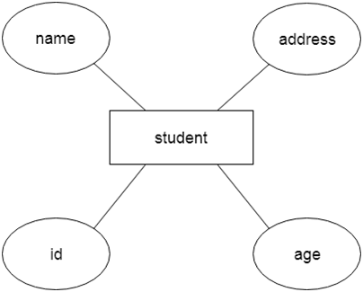

**Why ERDs?**

Entity Relationship Diagrams are a major data modeling tool and will help organize the data in your project into entities and define the relationships between the entities. This process has proved to enable the analyst to produce a good database structure so that the data can be stored and retrieved in a most efficient manner.

By using a graphical format it may help communication about the design between the designer and the user and the designer and the people who will implement it.

Component of ER Diagram

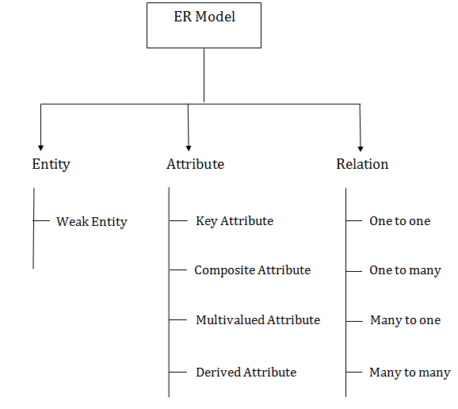

1. Entity:

An entity may be any object, class, person or place. In the ER diagram, an entity can be represented as rectangles.

Consider an organization as an example- manager, product, employee, department etc. can be taken as an entity.

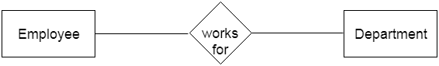

**a. Weak Entity**

An entity that depends on another entity called a weak entity. The weak entity doesn't contain any key attribute of its own. The weak entity is represented by a double rectangle.

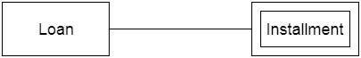

2. Attribute

The attribute is used to describe the property of an entity. Eclipse is used to represent an attribute.

**For example,** id, age, contact number, name, etc. can be attributes of a student.

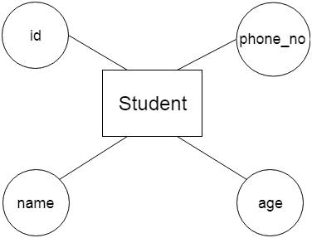

**a. Key Attribute**

The key attribute is used to represent the main characteristics of an entity. It represents a primary key. The key attribute is represented by an ellipse with the text underlined.

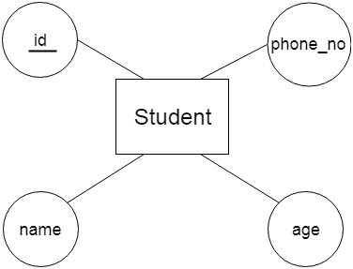

**b. Composite Attribute**

An attribute that composed of many other attributes is known as a composite attribute. The composite attribute is represented by an ellipse, and those ellipses are connected with an ellipse.

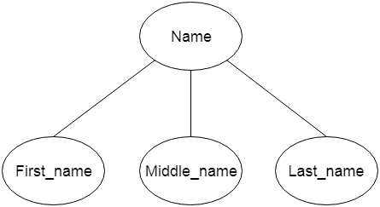

**c. Multivalued Attribute**

An attribute can have more than one value. These attributes are known as a multivalued attribute. The double oval is used to represent multivalued attribute.

**For example,** a student can have more than one phone number.

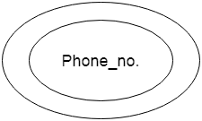

**d. Derived Attribute**

An attribute that can be derived from other attribute is known as a derived attribute. It can be represented by a dashed ellipse.

**For example,** A person's age changes over time and can be derived from another attribute like Date of birth.

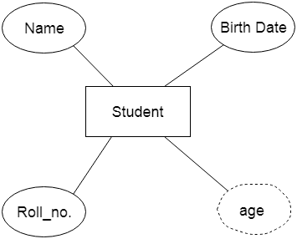

3. Relationship

A relationship is used to describe the relation between entities. Diamond or rhombus is used to represent the relationship.

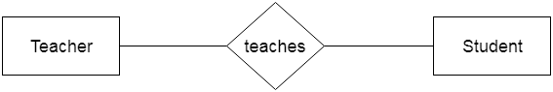

Types of relationship are as follows:

**a. One-to-One Relationship**

When only one instance of an entity is associated with the relationship, then it is known as one to one relationship.

**For example,** A female can marry to one male, and a male can marry to one female.

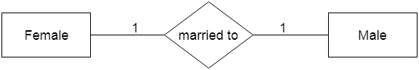

**b. One-to-many relationship**

When only one instance of the entity on the left, and more than one instance of an entity on the right associates with the relationship then this is known as a one-to-many relationship.

**For example,** Scientist can invent many inventions, but the invention is done by the only specific scientist.

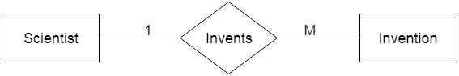

**c. Many-to-one relationship**

When more than one instance of the entity on the left, and only one instance of an entity on the right associates with the relationship then it is known as a many-to-one relationship.

**For example,** Student enrolls for only one course, but a course can have many students.

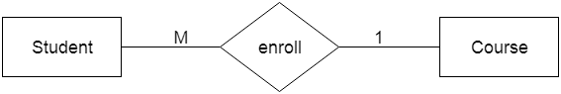

**d. Many-to-many relationship**

When more than one instance of the entity on the left, and more than one instance of an entity on the right associates with the relationship then it is known as a many-to-many relationship.

**For example,** Employee can assign by many projects and project can have many employees.

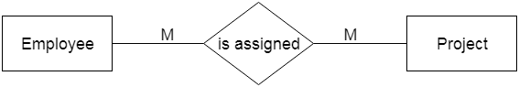

**Conclusion**: Above E-R diagram shows the student activities at college.

**Sample Questions:**

1. What is entity relationships diagram?
2. What is meant by entity relationship?
3. What is entity relationship model give an example?
4. What is purpose of entity relationship diagram?
5. What does an entity relationship diagram represent Why do accountants need to understand them?
6. What is entity and its types?
7. How do you draw an entity relationship diagram?
8. What do you mean by entity?
9. What are the types of entity relationship?
10. What are 3 types of relationships?
11. How do you identify relationships between entities?

**EXPERIMENT NO: 04**

**Title**: Reduce above mentioned E-R Diagram into tables.

**Aim:** Reduce above mentioned E-R Diagram into tables.

**Theory:**

Reduction of ER diagram to Table

The database can be represented using the notations, and these notations can be reduced to a collection of tables.

In the database, every entity set or relationship set can be represented in tabular form.

**The ER diagram is given below:**

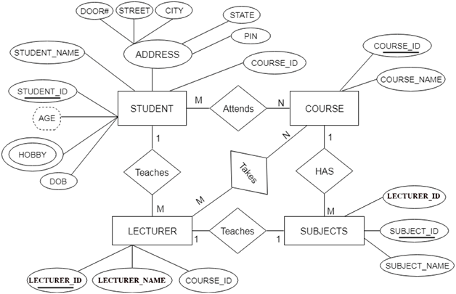

There are some points for converting the ER diagram to the table:

* **Entity type becomes a table.**

In the given ER diagram, LECTURE, STUDENT, SUBJECT and COURSE forms individual tables.

* **All single-valued attribute becomes a column for the table.**

In the STUDENT entity, STUDENT_NAME and STUDENT_ID form the column of STUDENT table. Similarly, COURSE_NAME and COURSE_ID form the column of COURSE table and so on.

* **A key attribute of the entity type represented by the primary key.**

In the given ER diagram, COURSE_ID, STUDENT_ID, SUBJECT_ID, and LECTURE_ID are the key attribute of the entity.

* **The multi valued attribute is represented by a separate table.**

In the student table, a hobby is a multi valued attribute. So it is not possible to represent multiple values in a single column of STUDENT table. Hence we create a table STUD_HOBBY with column name STUDENT_ID and HOBBY. Using both the column, we create a composite key.

* **Composite attribute represented by components.**

In the given ER diagram, student address is a composite attribute. It contains CITY, PIN, DOOR#, STREET, and STATE. In the STUDENT table, these attributes can merge as an individual column.

* **Derived attributes are not considered in the table.**

In the STUDENT table, Age is the derived attribute. It can be calculated at any point of time by calculating the difference between current date and Date of Birth.

Using these rules, you can convert the ER diagram to tables and columns and assign the mapping between the tables. Table structure for the given ER diagram is as below:

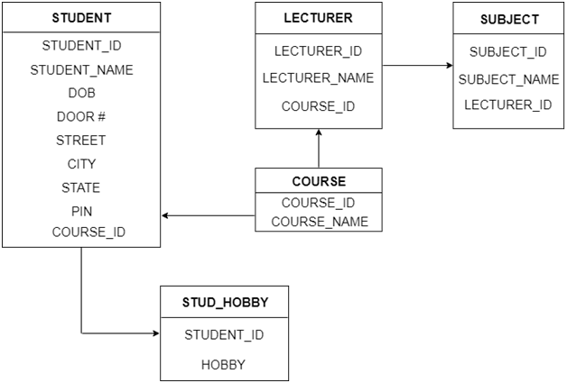

**Figure: Table structure**

**Conclusion:** Thus we reduce E R Diagram to table.

**Sample Questions**

* 1. How do you convert an ER diagram to a relational schema?
  2. How can ER diagrams reduce relational schema?
  3. How can we convert relationship sets with key constraints into table?